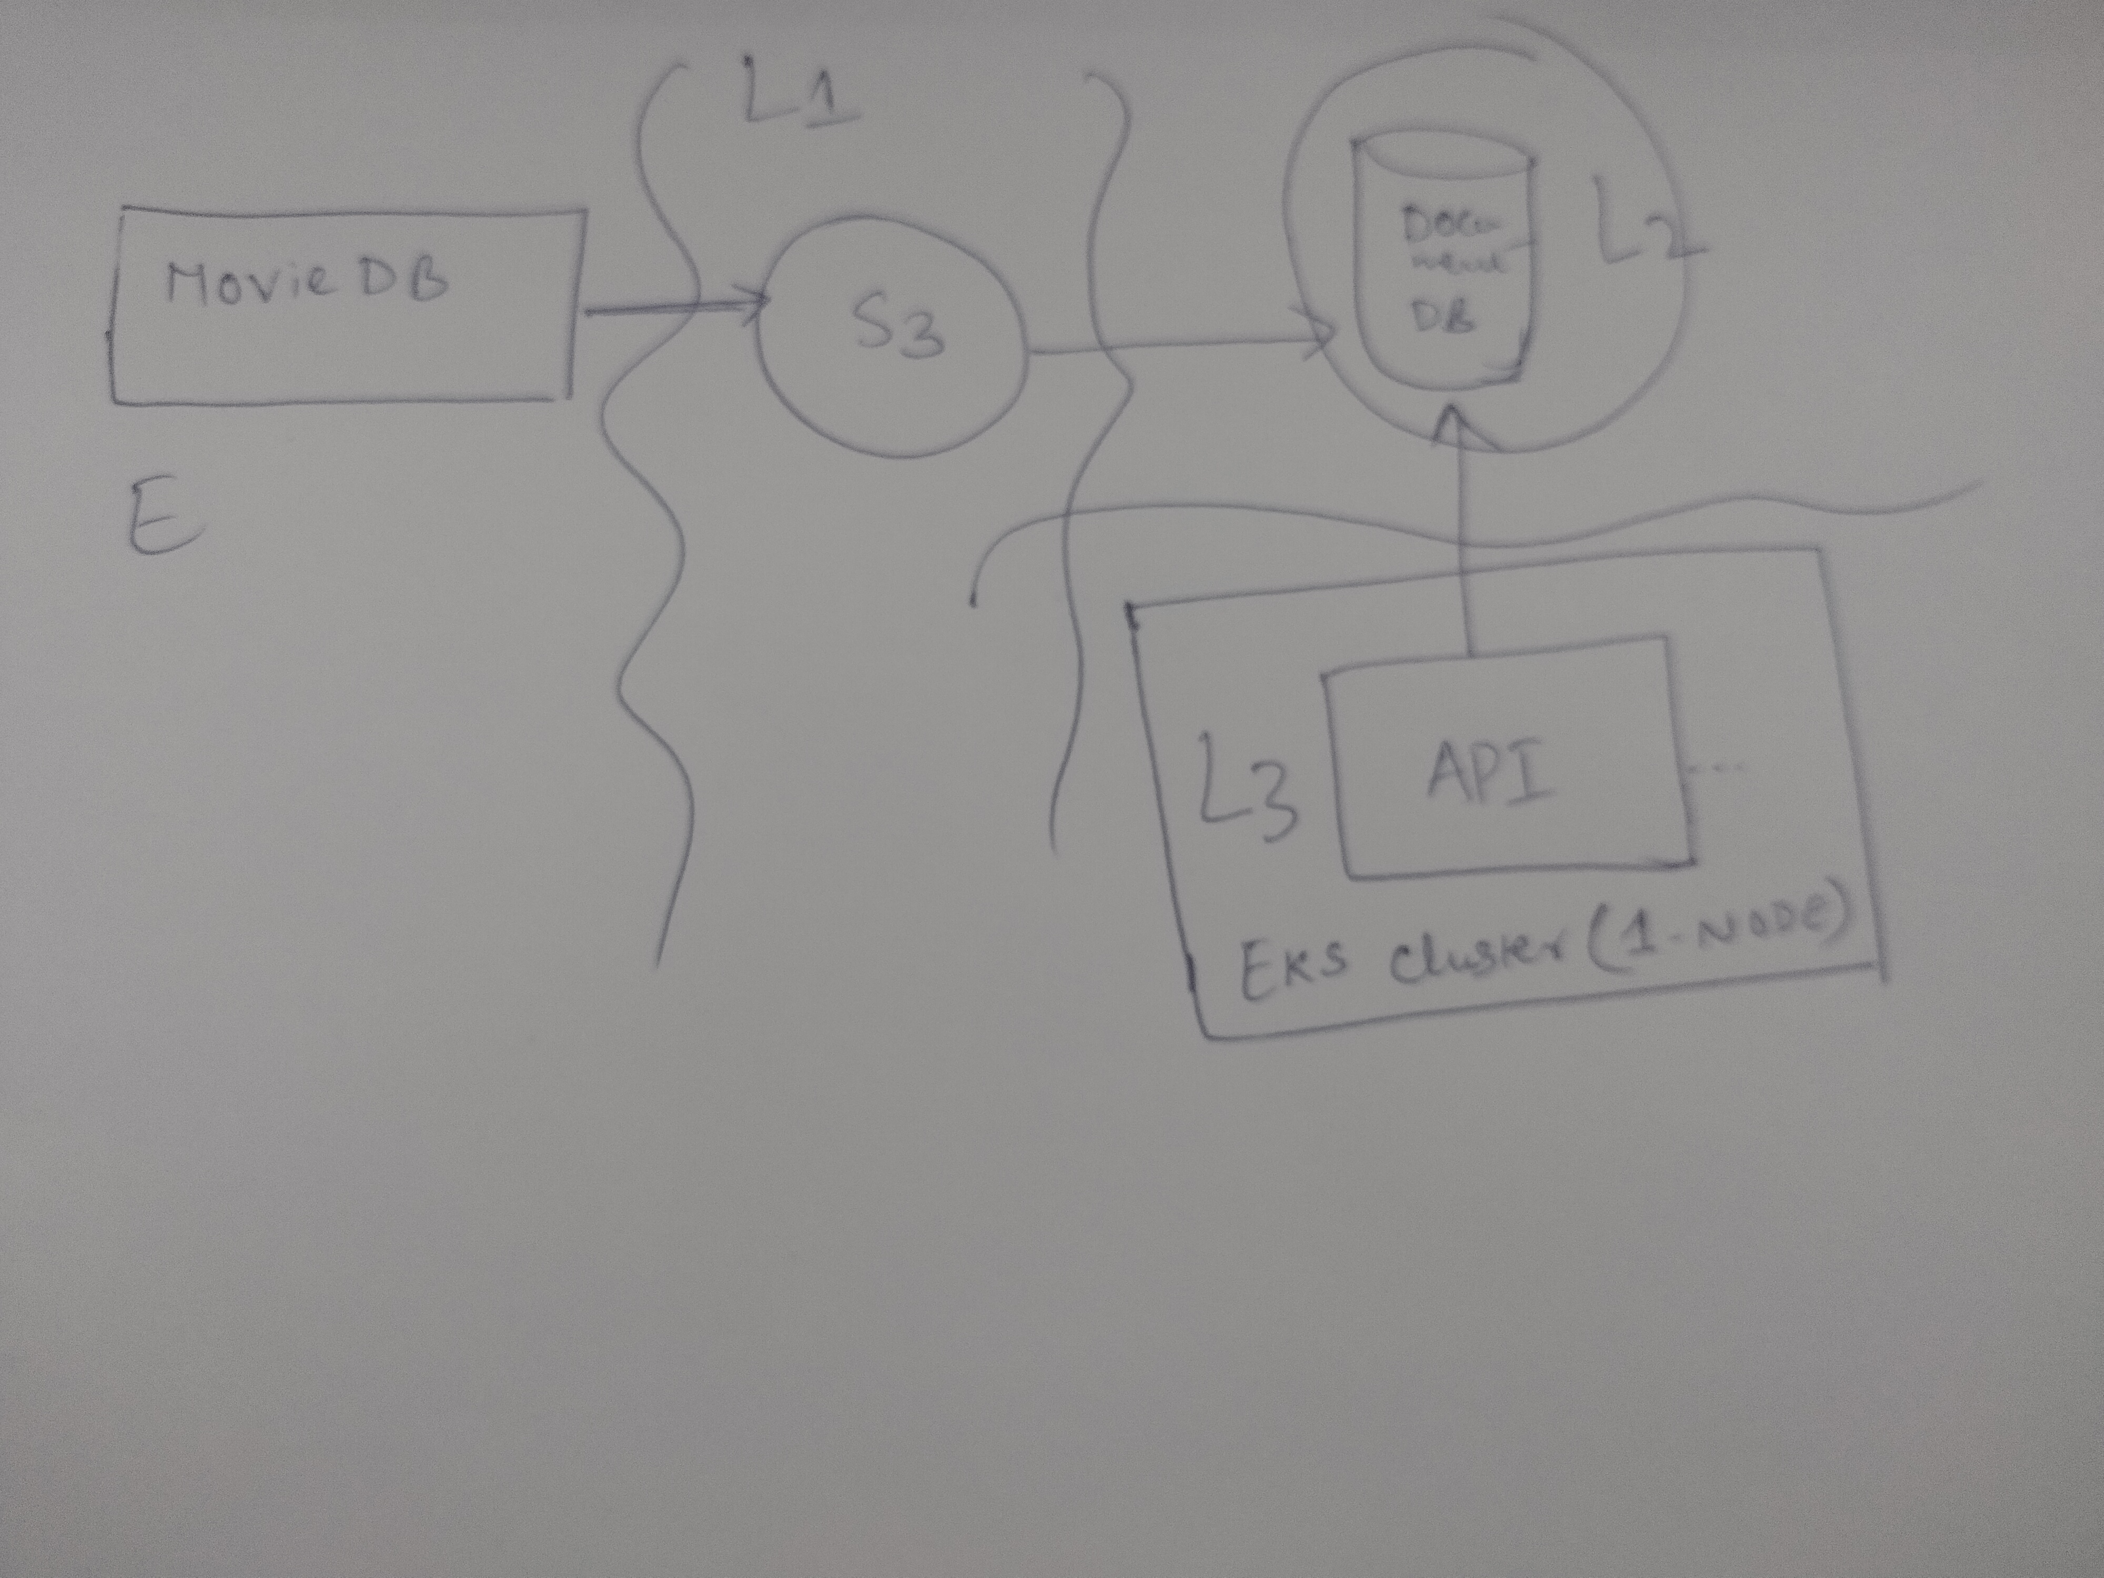

Based on the data flows, if one does elucidate potential threat vectors then we have the following items to address:

* **Application/API**
* Broken object level authorization
* Broken authentication
* Excessive data exposure
* Lack of resources and rate limiting
* Broken function level authorization
* Mass assignment
* Security misconfiguration
* Injection
* Improper assets management
* Insufficient logging and monitoring
  + I would like to employ Authentication and authorisation using AWS Cognito user pools and identity pools in tandem with API gateway and AWS IAM (role-based access and short-lived tokens/session tokens as opposed to long lived credentials)
  + Rate limiting will have to be enforced using API gateway. I have not implemented/configured this may also be employed using a WAF.
  + Injection and XSS attacks can also be enforced using WAF.
  + BOLA/BFLA can be addressed by having appropriate access controls similar to conventional web access controls such as no access unless authorised i.e. enforcement using policy end point and policy decision point.
* **Infrastructure**
  + All access must be enforced using AWS IAM roles among services – both for human and non-human access
  + Container and EKS security best practices must be codified.
    - <https://cheatsheetseries.owasp.org/cheatsheets/Docker_Security_Cheat_Sheet.html>
    - <https://owasp.org/www-project-kubernetes-top-ten/>
    - CI/CD or pipeline security must be employed
      * SCA analysis using opensource or commercial tool.
        + I used Snyk freeware to assess the code, hadolint as the docket linting tool and also Trivy to understand the posture or CVE/CWEs.
    - Data-at-rest and in-motion using TLS and all sensitive data or credentials must be encrypted or stored on secrets management. (Key-values must be encrypted using CMKs)